STOCK PRICE PREDICTION
Thesis Submitted in fulfilment of the Requirement for the degree
Of
Bachelor of Technology (B.Tech)
in
Department of Computer Science and Engineering
By
RUMON MUKHERJEE(Reg. No.- 171430110078 , Roll No.-500117011077)
RIMA PANJA(Reg. No.- 171430110074 , Roll No.-500117021073)
RITTIKA CHAKRABORTY(Reg. No.- 171430110076 , Roll No.-500117021075)
SWARNADIPA CHAKRABORTY(Reg. No.-171430110117 , Roll No.-500117021113)
BIPROJIT CHAKRABORTY(Reg. No.-171430110023 , Roll No.-500117011022)
Under the guidance of Mrs. Pallavi Das[ Assistant Prof.]

Guru Nanak Institute of Technology, Kolkata-700110
ACKNOWLEDGEMENT

We take this opportunity to express my profound gratitude and deep regards to my faculty Mrs. Pallavi Das for her exemplary guidance, monitoring and constant encouragement throughout the project. The help and guidance given by her, time to time shall carry us a long way in the journey of life on which we are about to embark.
We are grateful for the cooperation during the period of our assignment.
Date : 6th January, 2021

Rumon Mukherjee
Rima Panja
Rittika Chakraborty
Swarnadipa Chakraborty
Biprojit Chakraborty

Place : Sodepur, Panihati

GURUNANAK INSTITUTE OF TECHNOLOGY
DEPARTMENT OF COMPUTER SCIENCE AND ENGINEERING CERTIFICATE
This is to certify that the thesis entitled, “Stock Price Prediction” which is going to be submitted by Rumon Mukherjee (roll no-500117011077), Rima Panja (roll no-500117021073), Rittika Chakraborty (roll no-500117021075), Swarnadipa Chakraborty (roll no-500117021113), and Biprojit Chakraborty (roll no-500117011022),for the award of the degree of partial fulfilment of Bachelor of Technology in the branch Computer Science and Engineering of Guru Nanak Institute of Technology, is a record of bonafide research work carried out under the supervision and guidance of the undersigned. We have worked for nearly one year on the aforementioned subject at the Department of Computer Science and Engineering, Guru Nanak Institute of Technology, Kolkata and this has reached the standard fulfilment of the requirements and the regulation relating to the degree.
The contents of this thesis, in full or part, have not been submitted to any other university or institution for the award of any degree.

Supervisor
----------------------------
<Supervisor Name with Designation>
Department of Computer Science and Engineering
GNIT, Kolkata.

Head of the Department

-------------------------------
Mrs.Sangeeta Bhattacharya
Head of the Department
Department of Computer Science and Engineering,
GNIT, Kolkata

CONTENTS

 | Page no
- Abstract | 5
- Introduction | 6
- Literature Survey | 7 - 12
- Problem statement | 13
- Proposed System | 13
- System Model  - Software Requirement Specification | 14-23
- Implementation  - Modules  - Module Description | 24-27
- Experimental Results  - Test Results  - Screenshots | 28-41
- Conclusion and Future study | 42, 43
- References | 43

ABSTRACT
Predicting how the stock market will perform is one of the most difficult things to do. There are so many factors involved in the prediction – physical factors vs. psychological, rational and irrational behaviour, etc. All these aspects combine to make share prices volatile and very difficult to predict with a high degree of accuracy.
In this project, we will work with historical data about the stock prices of a publicly listed company. We will implement a mix of machine learning algorithms to predict the future stock price of this company, starting with simple algorithms like averaging and linear regression.

INTRODUCTION

Data : It can be any unprocessed fact, value, text, sound or picture that is not being interpreted and analyzed. Data is the most important part of all Machine Learning Without data, we can’t train and test any model and all modern research and automation will go vein. Machine Learning is all about prediction and accuracy.
Datasets: A collection of instances is a dataset and when working with machine learning methods we typically need a few datasets for different purposes.

Training Dataset: A dataset that we feed into our machine learning algorithm to train our model.

Testing Dataset: A dataset that we use to validate the accuracy of our model but is not used to train the model. It may be called the validation dataset.

LITERATURE SURVEY
Over the past two decades many important changes have taken place in the environment of financial markets. The development of powerful communication and trading facilities has enlarged the scope of selection for investors.
Forecasting stock return is an important financial subject that has attracted researchers’ attention for many years. It involves an assumption that fundamental information publicly available in the past has some predictive relationships to the future stock returns. In order to be able to extract such relationships from the available data, data mining techniques are new techniques that can be used to extract the knowledge from this data. For that reason, several researchers have focused on technical analysis and using advanced math and science. Extensive attention has been dedicated to the field of artificial intelligence and data mining techniques. Some models have been proposed and implemented using the above mentioned techniques, the authors of Tsang, P.M., Kwok, P., Choy, S.O., Kwan, R., Ng, S.C., Mak, J., Tsang, J., Koong, K., and Wong, T. made anempirical study on building a stock buying/selling alert system using back propagation neural networks (BPNN), their NN was codenamed NN5. The system was trained and tested with past price data from Hong Kong and Shanghai Banking Corporation Holdings over the period from January 2004 to December 2005. The empirical results showed that the implemented system was able to predict short-term price movement directions with accuracy about 74%.
The research by Wu, M.C., Lin, S.Y., and Lin, C.H., used decision tree technique to build on the work of Lin. where Lin tried to modify the filter rule that is to buy when the stock price rises k% above its past local low and sell when it falls k% from its past local high. The proposed modification to the filter rule was by combining three decision variables associated with fundamental analysis. An empirical test, using the stocks of electronics companies in Taiwan, showed Lin’s method outperformed the filter rule. According to Wu, M.C., Lin, S.Y., and Lin, C.H.,, in Lin’s work, the criteria for clustering trading points involved only the past information; the future information was not considered at all. The research by Wu, M.C., Lin, S.Y., and Lin, C.H., aimed to improve the filter rule and Lin’s study by considering both the past and the future information in clustering the trading points. The researchers used the data of Taiwan stock market and that of NASDAQ to carry out empirical tests. Test results showed that the proposed method outperformed both Lin’s method and the filter rule in the two stock markets.
The model of Wang, J.L., Chan, S.H. (2006) “Stock market trading rule discovery using two-layer bias decision tree”, applied the concept of serial topology and designed a new decision system, namely the two layerbias decision tree, for stock price prediction. The methodology developed by the authors differs from other studies in two respects;
first, to reduce the classification error, the decision model was modified into a bias decision model.
Second, a two-layer bias decision tree is used to improve purchasing accuracy. The empirical results indicated that the presented decision model produced excellent purchasing accuracy, and it significantly outperformed than random purchase.
The authors Enke, D., Thawornwong, S. presented an approach that used data mining methods and neural networks for forecasting stock market returns. An attempt has been made in this study to investigate the predictive power of financial and economic variables by adopting the variable relevance analysis technique in machine learning for data mining. The authors examined the effectiveness of the neural network models used for level estimation and classification. The results showed that the trading strategies guided by the neural network classification models generate higher profits under the same risk exposure than those suggested by other strategies.
The research by Cao, Q., Leggio, K.B., and Schniederjans, M.J., was basically a comparison between the work of Fama and French’s model and the artificial neural networks in order to try to predict the stock prices in the Chinese market. The purpose of this study is to demonstrate the accuracy of ANN in predicting stock price movement for firms traded on the Shanghai Stock Exchange. In order to demonstrate the accuracy of ANN, the authors made a comparative analysis between Fama and French’s model and the predictive power of the univariate and multivariate neural network models. The results from this study indicated that artificial neural networks offer an opportunity for investors to improve their predictive power in selecting stocks, and more importantly, a simple univariate model appears to be more successful at predicting returns than a multivariate model.
Al-Haddad et al., presented a study that aimed to provide evidence of whether or not the corporate governance & performance indicators of the Jordanian industrial companies listed at Amman Stock Exchange (ASE) are affected by variables that were proposed and to provide the important indicators of the relationship of corporate governance & firms’ performance that can be used by the Jordanian industrial firms to solve the agency problem. The study random sample consists of (44) Jordanian industrial firms. The study founds a positive direct relationship between corporate governance and corporate performance.
Hajizadeh et al. provided an overview of application of data mining techniques such as decision tree, neural network, association rules, and factor analysis and in stock markets. Prediction stock price or financial markets has been one of the biggest challenges to the AI community. Various technical, fundamental, and statistical indicators have been proposed and used with varying results. Soni surveyed some recent literature in the domain of machine learning techniques and artificial intelligence used to predict stock market movements.
Artificial Neural Networks (ANNs) are identified to be the dominant machine learning technique in stock market prediction area.
El-Baky et al., proposed a new approach for fast forecasting of stock market prices. The proposed approach uses new high speed time delay neural networks (HSTDNNs). The authors used the MATLAB tool to simulate results to confirm the theoretical computations of the approach.
V. Vamitha, M. Jeyanthi, S. Rajaram and T. Revathi,s research about Multivariate Markov Chain also gave a new approach in the stock market prediction systems. Since 1993 researchers proposed many methods for forecasting enrollments, Temperature prediction, stock price etc in time variant and time invariant first order, higher order, two factor and dual variables. The proposed method gets higher average forecasting accuracy rate than some of the existing methods on temperature prediction.
Anass Nahil proposed a new method on stock market prediction which will help many investors to invest their money in right time by which they will get more benefit in near future. Their proposed method was about support vector machine (SVM). It is a popular tool in time series forecasting for the capital investment industry. This machine learning technique which is based on a discriminative classiﬁer algorithm, forecasts more accurately the ﬁnancial data. By examining the stock price of 5 Moroccan banks, the experiment shows that the SVM can perform better when we add the global evolution of the market to the independent variables. To express the global evolution of the market, three indices of the Casablanca Stock Exchange are used : MASI, MADEX and Banks Sector Index.
Narendra Pahuja, Abhishek Oturkar, Kailash Sharma, Jatin Shrivastava, Dimple Bohra’s ARIMA model made a huge change in stock market prediction. Over the years it is observed that stock market data is nonlinear, chaotic & dynamic. The stock data which is published from the Bombay Stock Exchange (BSE) & National Stock Exchange (NSE) has been used with the model developed for the prediction of stock price. From the results which are obtained, we come to the conclusion that for short-term prediction the ARIMA model has a great potential & also it shows competence with the already present methods for stock price prediction.
Mahantesh Angadi, Amogh Kulkarni Sai proposed the method of stock market prediction by using Data Mining Techniques with R. In terms of predicting directional changes in the Standard & Poor’s 500 index, both for individual companies and the overall index, we show that this technique is competitive with other state-of-the-art approaches.

PROBLEM STATEMENT
We’ll dive into the implementation part of this project soon, but first it’s important to establish what we’re aiming to solve. Broadly, stock market analysis is divided into two parts – Fundamental Analysis and Technical Analysis.
- Fundamental Analysis involves analyzing the company’s future profitability on the basis of its current business environment and financial performance.
- Technical Analysis, on the other hand, includes reading the charts and using statistical figures to identify the trends in the stock market.
PROPOSED SYSTEM
This project determines the stock prices prediction of any company.
The project also represent the graphical summary of :-
1.Open price stock in a year.
2.Actual Price and predicted Price.

SYSTEM MODEL
REQUIREMENT SPECIFICATION
The following requirement that is used for making this project is given below:
HARDWARE REQUIREMENTS

PC with 4GB RAM and sufficient space.

SOFTWARE REQUIREMENTS

Python Anaconda Navigator

Jupyter notebook

Some python libraries:

i.) Numpy

ii.) Pandas

iii.) Matplotlib

iv.) Seaborn
v.) MinMaxScaler preprocessing class from the
scikit-learn library.
vi.) A couple of modules like Sequential,
Dense, LSTM, Dropout from Keras library
vii.) tensorflow to support Keras
viii.) Dash python framework

Different Machine Learning Algorithm

Decision Tree and Random Forest

Logistic Regression Algorithm
- LSTM (Long Short Term Memory) Neural
Network

Anaconda Navigator

Anaconda Navigator is a desktop graphical user interface (GUI) included in Anaconda® distribution that allows you to launch applications and easily manage conda packages, environments, and channels without using command-line commands. Navigator can search for packages on Anaconda Cloud or in a local Anaconda Repository. It is available for Windows, macOS, and Linux.

How to install Anaconda Navigator

To install Anaconda Navigator go to the link

http://www.anaconda.com

After clicking this link you will see the below page will appear.



Then click on “ Getting Started” on the right button.

After clicking on this page you will see the below page.

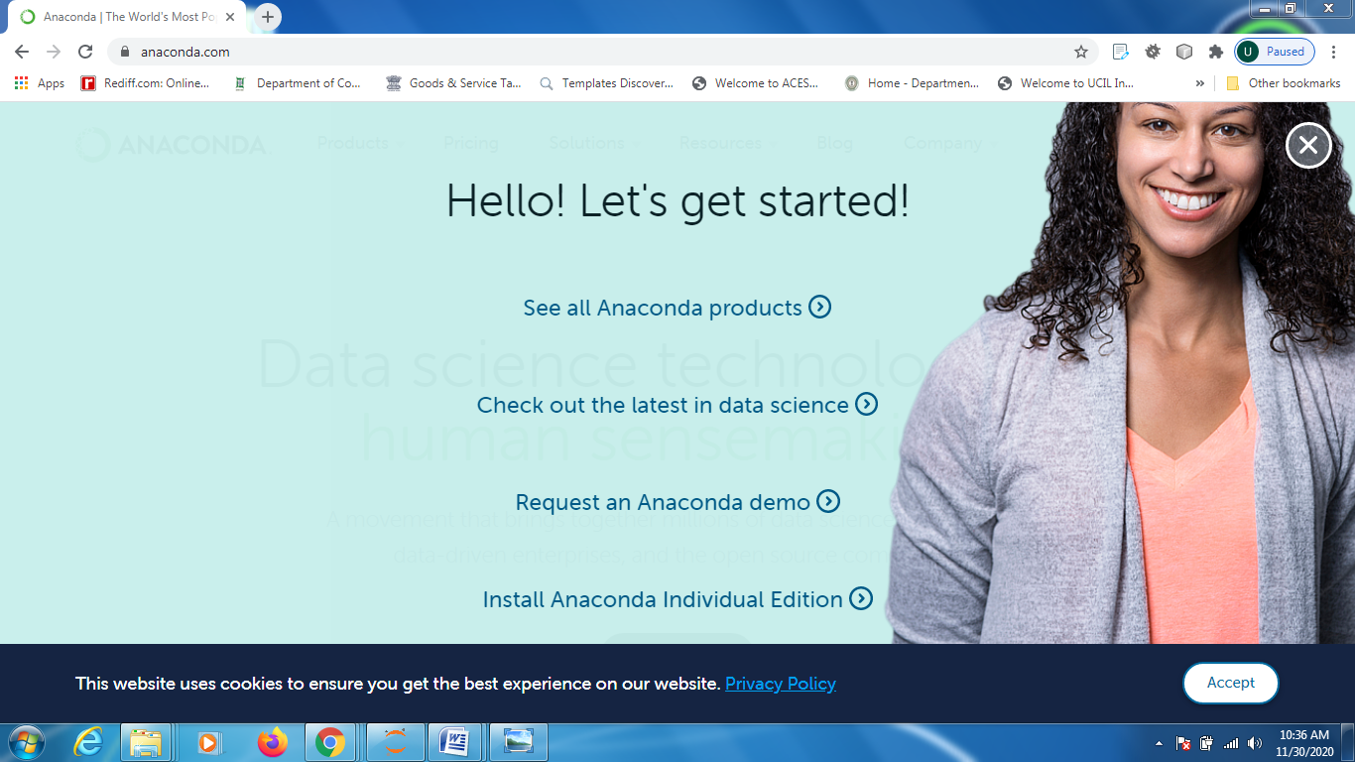

Then click on “Install Anaconda individual Edition” (4th option)

After clicking on the option above you will see the below page

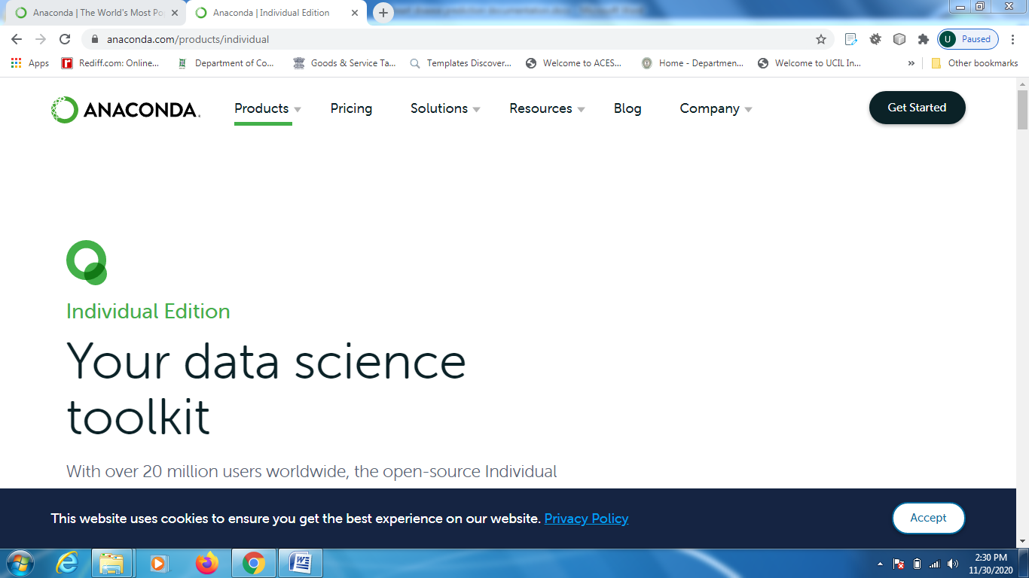

Scroll down the above page and you will find the below page then click on “install anaconda”.

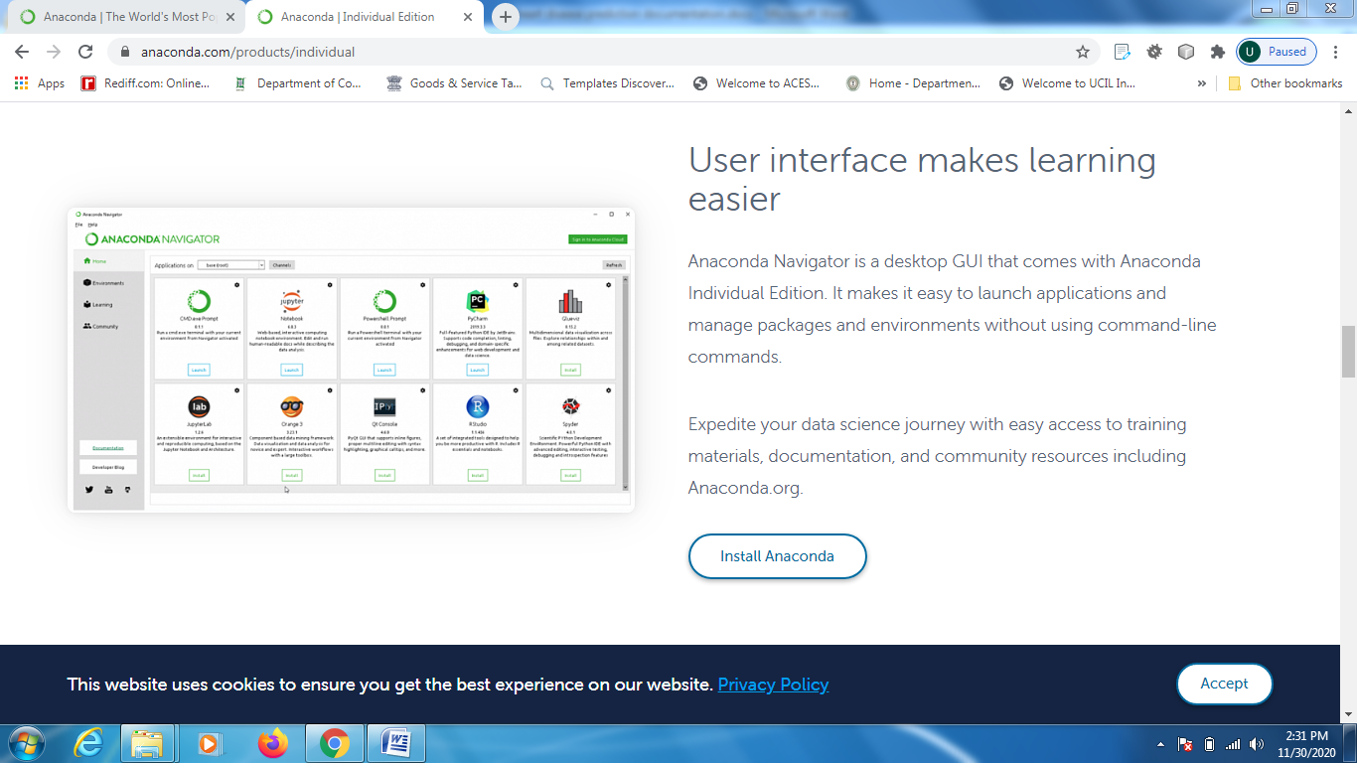

After installing Anaconda navigator we have to install “JUPYTER NOTEBOOK”

2..Jupyter Notebook

The Jupyter Notebook is a Python-based user interface where users can work with an ordered list of input/output cells to achieve Python Web server related tasks and deposit code solutions.

After installing Anaconda navigator go to the start button and click on Anaconda Navigator we will find the below page.
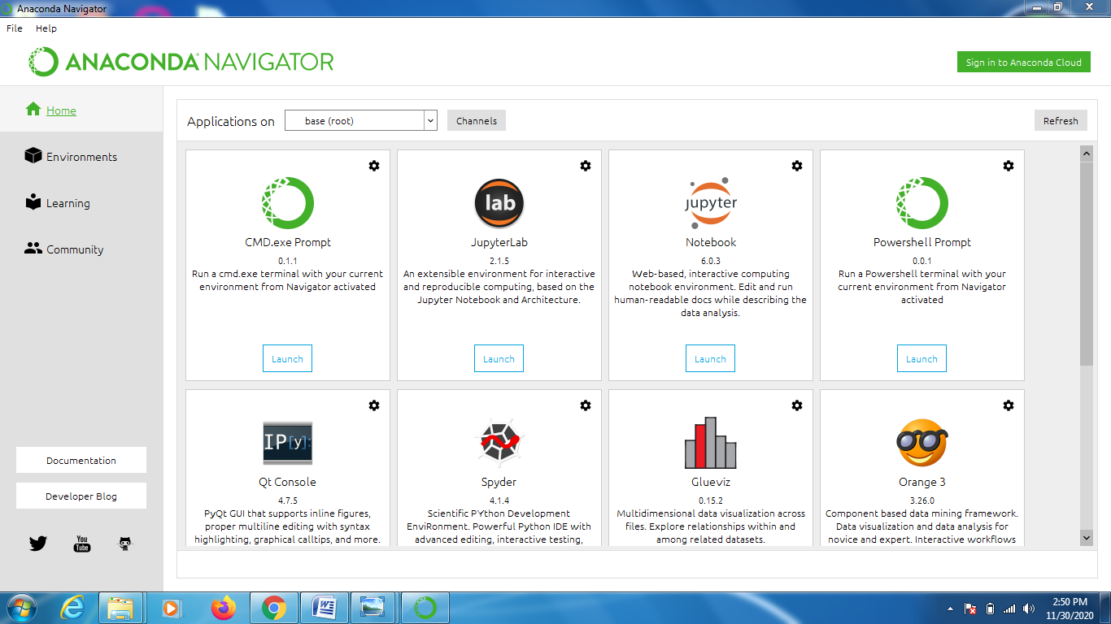

Now click on” Launch Button” of the JupyterNotebook i.eon first row and third one. In This way our Jupyter Notebook is installed.

SOME PYTHON LIBRARIES:

There are some of the Python libraries that are

used to make this project.

1.)NUMPY:
NumPy is a python library used for working with arrays.
It also has functions for working in domain of linear algebra, fourier transform, and matrices.
NumPy was created in 2005 by Travis Oliphant. It is an open source project and you can use it freely.
NumPy stands for Numerical Python.
It is so important for Data Science it that
Almost all of the libraries in the PyData Ecosystem rely on Numpy as one of their main building blocks.

How to InstallNumpy:

IIIf you have Anaconda you can go to the Anaconda command prompt and type:

1.)conda install numpy.

or

2.)Pip install numpy

2.)Pandas:
Pandas is a fast, powerful, flexible, and easy to use open-source data analysis and manipulation tool. It is the most common tool used by Data analyst Data scientists working with data.

How to Install Pandas:

IIIf you have Anaconda you can go to the Anaconda command prompt and type:

`1.)pip install pandas.

3.)Matplotlib:

Matplotlib is a low level graph plotting library in python that serves as a visualization utility.
Matplotlib was created by John D. Hunter.
Matplotlib is open source and we can use it freely.
Matplotlib is mostly written in python, a few segments are written in C, Objective-C and Javascript for Platform compatibility.

How to install Matplotlib:

If you have Anaconda you can go to the Anaconda command prompt and type:

1.)conda install matplotlib

or

2.)pip install matplotlib

4. Seaborn:

Seaborn is a library for making statistical graphics in Python. It builds on top of matplotlib and integrates closely with pandas data structures. Seaborn helps you explore and understand your data.
5. scikit-learn’s MinMaxScaler :
Sklearn provides another option when it comes to normalizing data: MinMaxScaler(). Machine Learning algorithms tend to perform better or converge faster when the different features (variables) are on a smaller scale. Thus, it is common practice to normalize the data before training machine learning models on it. Normalization also makes the training process less sensitive to the scale of the features. This results in getting better coefficients after training.
LSTMs are sensitive to the scale of the input data, specifically when the sigmoid (default) or tanh activation functions are used. It can be a good practice to rescale the data to the range of 0-to-1, also called normalizing. We can easily normalize the dataset using the MinMaxScaler preprocessing class from the scikit-learn library.

6. Keras Library :
In order to build the LSTM, we need to import a couple of modules
from Keras :
- Sequential for initializing the neural network
- Dense for adding a densely connected neural network layer
- LSTM for adding the Long Short-Term Memory layer
- Dropout for adding dropout layers that prevent overfitting
To install Keras, run a command on command prompt :
pip install Keras
Keras 2.4.3 is used in this project.

7. Dash Python Framework :
In this project, we will build a dashboard to analyze stocks. Dash is a python framework that provides an abstraction over flask and react.js to build analytical web applications. Dash is an open source library, and is ideal for building data visualization apps with highly custom user interfaces in pure Python. It's particularly suited for anyone who works with data in Python.

To install dash, run the below command in the terminal :-
pip3 install dash
pip3 install dash-html-components
pip3 install dash-core-components

Implementation:

MODULE NAME:

Linear Regression Algorithm

Regression is a method of modelling a target value based on independent predictors. This method is mostly used for forecasting and finding out cause and effect relationship between variables. Regression techniques mostly differ based on the number of independent variables and the type of relationship between the independent and dependent variables.
Simple linear regression is a type of regression analysis where the number of independent variables is one and there is a linear relationship between the independent(x) and dependent(y) variable.
Linear Regression algorithm is a supervised machine learning algorithm where predicted output is continuous and has a constant slope.It is used to predict value within a continuous slope.(e.g.sale,price)rather than trying to classifying them into categories.(e.g. cat,dog)

LSTM (Long Short Term Memory) Neural Network :
Long-Short-Term Memory Neural Network belongs to the family of deep learning algorithms. It has an advantage over traditional neural networks due to its capability to process the entire sequence of data. Its architecture comprises the cell, input gate, output gate and forget gate. The cell remembers values over arbitrary time intervals, and the three gates regulate the flow of information into and out of the cell. The cell of the model is responsible for keeping track of the dependencies between the elements in the input sequence. The input gate controls the extent to which a new value flows into the cell, the forget gate controls the extent to which a value remains in the cell, and the output gate controls the extent to which the value in the cell is used to compute the output activation of the LSTM unit.
Stock Prediction using LSTM :
In this project, the future stock prices of Tata Beverages from Tata Global Beverages Limited, National Stock Exchange of India are predicted using the LSTM Recurrent Neural Network. Our task is to predict stock prices for a few days, which is a time series problem. The LSTM model is very popular in time-series forecasting, and this is the reason why this model is chosen in this task. The historical prices are collected automatically from excel dataset using the DataFrame library of python. We have used 5 years of historical price data, from 08.10.2013 to 08.10.2018.
After preprocessing, only dates and OHLC (Open, High, Low, Close) columns, a total of 5 columns, are taken as these columns have main significance in the dataset. The LSTM model is trained on this entire dataset, and for the testing purpose, a new dataset is fetched for an unseen duration from Tata Global dataset, and for some companies like Apple, Facebook, Microsoft and Testla datasets. The stock prices for this new duration and the named companies will be predicted by the already trained LSTM model, and the predicted prices will be plotted against the original prices to visualize the model’s accuracy, in the dashboard of the user interface created with Dash python framework.

Dataset and UI Description

Within the dataset and dashboard in the user interface one will encounter the following:
- The date - "Date"
- The opening price of the stock - "Open"
- The high price of that day - "High"
- The low price of that day - "Low"
- The closed price of that day - "Close"
- The amount of stocks traded during that day - "Volume"
- The stock's closing price that has been amended to include any distributions/corporate actions that occurs before next days open - "Adjusted Close"
- http://www.kaggle.com
- Link to download excel Dataset for TATA Global Beverage : https://data-flair.training/blogs/download-tata-global-beverages-stocks-data/
- Link to download excel Dataset for Testla, Facebook, Apple & Microsoft : https://data-flair.training/blogs/download-stocks-price-data/

EXPERIMENTAL RESULTS
TEST RESULTS
Linear Regression Algorithm:
(To determine the Stock Price market Prediction)
import pandas as pd
import numpy as np
import matplotlib.pyplot as plt
from sklearn import metrics
%matplotlib inline
dataset = pd.read_csv('tesla.csv')
dataset.head()
dataset['Date'] = pd.to_datetime(dataset.Date)
dataset.shape
dataset.drop('AdjClose',axis = 1,inplace = True)
dataset.head()
dataset.isnull().sum()
dataset.isna().sum()
dataset.info()
dataset.describe()
print(len(dataset))
dataset['Open'].plot(figsize=(16,4))
# TRAINING DATA
X = dataset[['Open','High','Low','Volume']]
y = dataset['Close']
fromsklearn.model_selection import train_test_split

X_train, X_test, y_train, y_test = train_test_split(X, y, random_state=0)
X_train.shape
X_test.shape
from sklearn.linear_model import LinearRegression
from sklearn.metrics import confusion_matrix, accuracy_score
regressor = LinearRegression()
regressor.fit(X_train,y_train)
print(regressor.coef_)
print(regressor.intercept_)
predicted = regressor.predict(X_test)
print(X_test)
predicted.shape
dframe=pd.DataFrame(y_test,predicted)
dfr=pd.DataFrame({'Actual Price':y_test,'PredictedPrice':predicted})
print(dfr)
dfr.head(91)
fromsklearn.metrics import confusion_matrix, accuracy_score
regressor.score(X_test,y_test)
import math
print('MAE:', metrics.mean_absolute_error(y_test, predicted))
print('MSE:', metrics.mean_squared_error(y_test, predicted))
print('RMSE:', np.sqrt(metrics.mean_squared_error(y_test, predicted)))
graph=dfr.head(10)
graph.plot(kind='bar')
LSTM(Long Short-Term Memory)
#imports:
import pandas as pd
import numpy as np
import matplotlib.pyplot as plt
%matplotlib inline
from matplotlib.pylab import rcParams
rcParams['figure.figsize']=20,10
from keras.models import Sequential
from keras.layers import LSTM,Dropout,Dense
from sklearn.preprocessing import MinMaxScaler
df=pd.read_csv("NSE-TATA.csv")
df.head()
df["Date"] =pd.to_datetime(df.Date,format="%Y-%m-%d")
df.index=df['Date']
plt.figure(figsize=(16,8))
plt.plot(df["Close"],label='Close Price history')
data=df.sort_index(ascending=True,axis=0)
new_dataset=pd.DataFrame(index=range(0,len(df)),columns=['Date','Close'])
for i in range(0,len(data)):
new_dataset["Date"][i]=data['Date'][i]
new_dataset["Close"][i]=data["Close"][i]
scaler=MinMaxScaler(feature_range =(0,1))
final_dataset=new_dataset.values
train_data=final_dataset[0:987,:]
valid_data=final_dataset[987:,:]
new_dataset.index=new_dataset.Date
new_dataset.drop("Date",axis=1,inplace=True)
# Normalize the new filtered dataset:
scaler=MinMaxScaler(feature_range=(0,1))
scaled_data=scaler.fit_transform(final_dataset)
x_train_data,y_train_data=[],[]
for i in range(60,len(train_data)):
x_train_data.append(scaled_data[i-60:i,0])
y_train_data.append(scaled_data[i,0])
x_train_data,y_train_data=np.array(x_train_data),np.array(y_train_data)
x_train_data=np.reshape(x_train_data,(x_train_data.shape[0],x_train_data.shape[1],1))
#Build and train the LSTM model:
lstm_model=Sequential()
lstm_model.add(LSTM(units=50,return_sequences=True,input_shape=(x_train_data.shape[1],1)))
lstm_model.add(LSTM(units=50))
lstm_model.add(Dense(1))
inputs_data=new_dataset[len(new_dataset)-len(valid_data)-60:].values
inputs_data=inputs_data.reshape(-1,1)
inputs_data=scaler.transform(inputs_data)
lstm_model.compile(loss='mean_squared_error',optimizer='adam')
lstm_model.fit(x_train_data,y_train_data,epochs=1,batch_size=1,verbose=2)
#Take a sample of a dataset to make stock price predictions using the LSTM model:
X_test=[]
for i in range(60,inputs_data.shape[0]):
X_test.append(inputs_data[i-60:i,0])
X_test=np.array(X_test)
X_test=np.reshape(X_test,(X_test.shape[0],X_test.shape[1],1))
predicted_closing_price=lstm_model.predict(X_test)
predicted_closing_price=scaler.inverse_transform(predicted_closing_price)
# Save the LSTM model:
lstm_model.save("saved_model.h5")
# Visualize the predicted stock costs with actual stock costs:
train_data=new_dataset[:987]
valid_data=new_dataset[987:]
valid_data['Predictions'] =predicted_closing_price
plt.plot(train_data["Close"])
plt.plot(valid_data[['Close',"Predictions"]])

Build the dashboard using Plotly dash
import dash
import dash_core_components as dcc
import dash_html_components as html
import pandas as pd
import plotly.graph_objs as go
from dash.dependencies import Input, Output
from keras.models import load_model
from sklearn.preprocessing import MinMaxScaler
import numpy as np
app = dash.Dash()
server = app.server
scaler=MinMaxScaler(feature_range=(0,1))
df_nse = pd.read_csv("./NSE-TATA.csv")
df_nse["Date"]=pd.to_datetime(df_nse.Date,format="%Y-%m-%d")
df_nse.index=df_nse['Date']
data=df_nse.sort_index(ascending=True,axis=0)
new_data=pd.DataFrame(index=range(0,len(df_nse)),columns=['Date','Close'])
for i in range(0,len(data)):
new_data["Date"][i]=data['Date'][i]
new_data["Close"][i]=data["Close"][i]
new_data.index=new_data.Date
new_data.drop("Date",axis=1,inplace=True)
dataset=new_data.values
train=dataset[0:987,:]
valid=dataset[987:,:]
scaler=MinMaxScaler(feature_range=(0,1))
scaled_data=scaler.fit_transform(dataset)
x_train,y_train=[],[]
for i in range(60,len(train)):
x_train.append(scaled_data[i-60:i,0])
y_train.append(scaled_data[i,0])
x_train,y_train=np.array(x_train),np.array(y_train)
x_train=np.reshape(x_train,(x_train.shape[0],x_train.shape[1],1))
model=load_model("saved_model.h5")
inputs=new_data[len(new_data)-len(valid)-60:].values
inputs=inputs.reshape(-1,1)
inputs=scaler.transform(inputs)
X_test=[]
for i in range(60,inputs.shape[0]):
X_test.append(inputs[i-60:i,0])
X_test=np.array(X_test)
X_test=np.reshape(X_test,(X_test.shape[0],X_test.shape[1],1))
closing_price=model.predict(X_test)
closing_price=scaler.inverse_transform(closing_price)
train=new_data[:987]
valid=new_data[987:]
valid['Predictions']=closing_price
df= pd.read_csv("./stock_data.csv")
app.layout = html.Div([
html.H1("Stock Price Analysis Dashboard", style={"textAlign": "center"}),
dcc.Tabs(id="tabs", children=[
dcc.Tab(label='NSE-TATAGLOBAL Stock Data',children=[
html.Div([
html.H2("Actual closing price",style={"textAlign": "center"}),
dcc.Graph(
id="Actual Data",
figure={
"data":[
go.Scatter(
x=train.index,
y=valid["Close"],
mode='markers'
)
],
"layout":go.Layout(
title='scatter plot',
xaxis={'title':'Date'},
yaxis={'title':'Closing Rate'}
)
}
),
html.H2("LSTM Predicted closing price",style={"textAlign": "center"}),
dcc.Graph(
id="Predicted Data",
figure={
"data":[
go.Scatter(
x=valid.index,
y=valid["Predictions"],
mode='markers'
)
],
"layout":go.Layout(
title='scatter plot',
xaxis={'title':'Date'},
yaxis={'title':'Closing Rate'}
)
}
)
])
]),
dcc.Tab(label='Facebook Stock Data', children=[
html.Div([
html.H1("Facebook Stocks High vs Lows",
style={'textAlign': 'center'}),
dcc.Dropdown(id='my-dropdown',
options=[{'label': 'Tesla', 'value': 'TSLA'},
{'label': 'Apple','value': 'AAPL'},
{'label': 'Facebook', 'value': 'FB'},
{'label': 'Microsoft','value': 'MSFT'}],
multi=True,value=['FB'],
style={"display": "block", "margin-left": "auto",
"margin-right": "auto", "width": "60%"}),
dcc.Graph(id='highlow'),
html.H1("Facebook Market Volume", style={'textAlign': 'center'}),
dcc.Dropdown(id='my-dropdown2',
options=[{'label': 'Tesla', 'value': 'TSLA'},
{'label': 'Apple','value': 'AAPL'},
{'label': 'Facebook', 'value': 'FB'},
{'label': 'Microsoft','value': 'MSFT'}],
multi=True,value=['FB'],
style={"display": "block", "margin-left": "auto",
"margin-right": "auto", "width": "60%"}),
dcc.Graph(id='volume')
], className="container"),
])
])
])
@app.callback(Output('highlow', 'figure'),
[Input('my-dropdown', 'value')])
def update_graph(selected_dropdown):
dropdown = {"TSLA": "Tesla","AAPL": "Apple","FB": "Facebook","MSFT": "Microsoft",}
trace1 = []
trace2 = []
for stock in selected_dropdown:
trace1.append(
go.Scatter(x=df[df["Stock"] == stock]["Date"],
y=df[df["Stock"] == stock]["High"],
mode='lines', opacity=0.7,
name=f'High {dropdown[stock]}',textposition='bottom center'))
trace2.append(
go.Scatter(x=df[df["Stock"] == stock]["Date"],
y=df[df["Stock"] == stock]["Low"],
mode='lines', opacity=0.6,
name=f'Low {dropdown[stock]}',textposition='bottom center'))
traces = [trace1, trace2]
data = [val for sublist in traces for val in sublist]
figure = {'data': data,
'layout': go.Layout(colorway=["#5E0DAC", '#FF4F00', '#375CB1',
'#FF7400', '#FFF400', '#FF0056'],
height=600,
title=f"High and Low Prices for {', '.join(str(dropdown[i]) for i in selected_dropdown)} Over Time",
xaxis={"title":"Date",
'rangeselector': {'buttons': list([{'count': 1, 'label': '1M',
'step': 'month',
'stepmode': 'backward'},
{'count': 6, 'label': '6M',
'step': 'month',
'stepmode': 'backward'},
{'step': 'all'}])},
'rangeslider': {'visible': True}, 'type': 'date'},
yaxis={"title":"Price (USD)"})}
return figure
@app.callback(Output('volume', 'figure'),
[Input('my-dropdown2', 'value')])
def update_graph(selected_dropdown_value):
dropdown = {"TSLA": "Tesla","AAPL": "Apple","FB": "Facebook","MSFT": "Microsoft",}
trace1 = []
for stock in selected_dropdown_value:
trace1.append(
go.Scatter(x=df[df["Stock"] == stock]["Date"],
y=df[df["Stock"] == stock]["Volume"],
mode='lines', opacity=0.7,
name=f'Volume {dropdown[stock]}', textposition='bottom center'))
traces = [trace1]
data = [val for sublist in traces for val in sublist]
figure = {'data': data,
'layout': go.Layout(colorway=["#5E0DAC", '#FF4F00', '#375CB1',
'#FF7400', '#FFF400', '#FF0056'],
height=600,
title=f"Market Volume for {', '.join(str(dropdown[i]) for i in selected_dropdown_value)} Over Time",
xaxis={"title":"Date",
'rangeselector': {'buttons': list([{'count': 1, 'label': '1M',
'step': 'month',
'stepmode': 'backward'},
{'count': 6, 'label': '6M',
'step': 'month',
'stepmode': 'backward'},
{'step': 'all'}])},
'rangeslider': {'visible': True}, 'type': 'date'},
yaxis={"title":"Transactions Volume"})}
return figure
if __name__=='__main__':
app.run_server(debug=True)

SCREENSHOTS
1.a)Graph to represent the open stock price in a year.
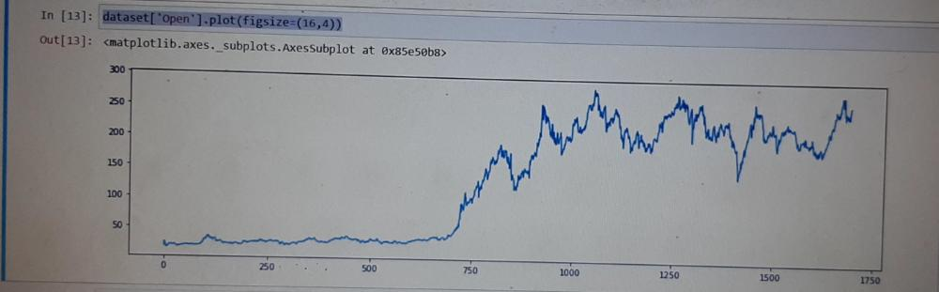
b) Graph to represent the close stock price in a year.
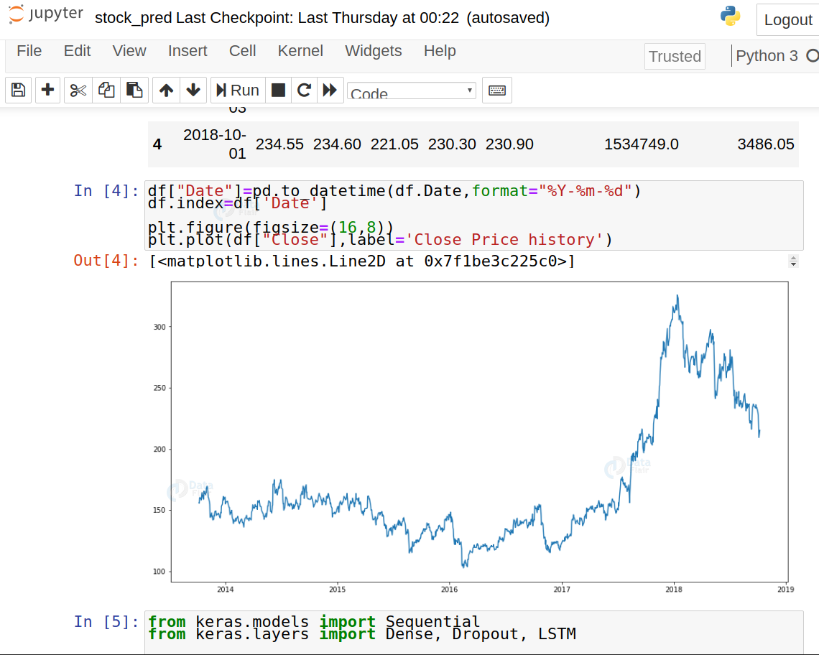

2.a)Graph to represent the actual price and predicted price.
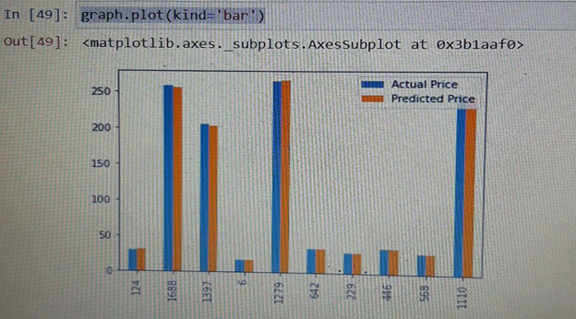
b)

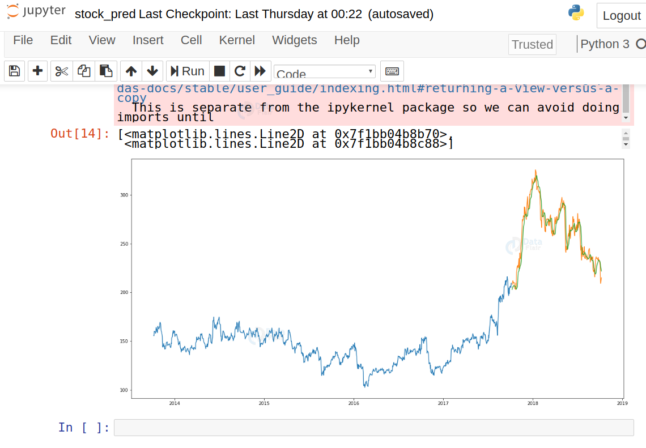

Stock Price analysis Dashboard Website without any data
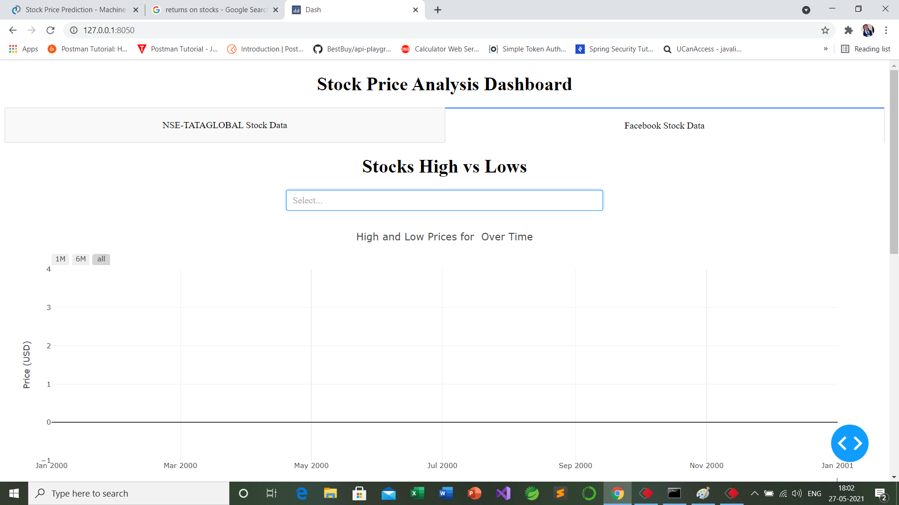
Stock Price analysis Dashboard Website showing the dropdown box
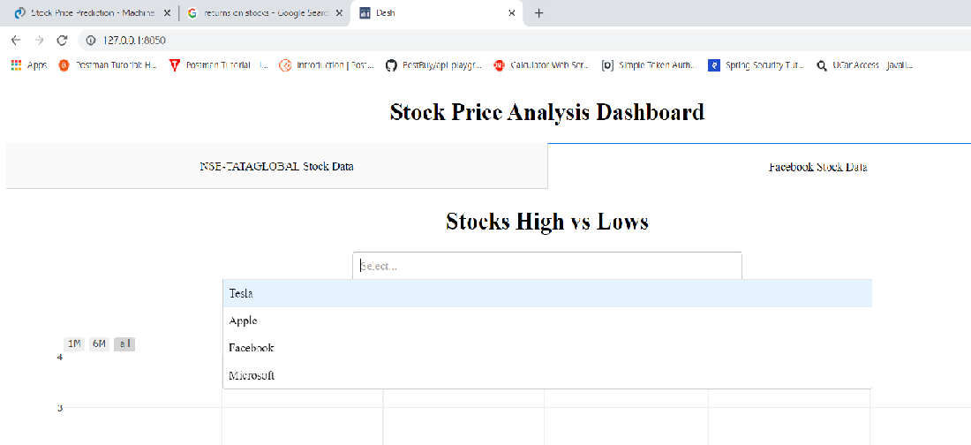
Some Snapshots of the website :
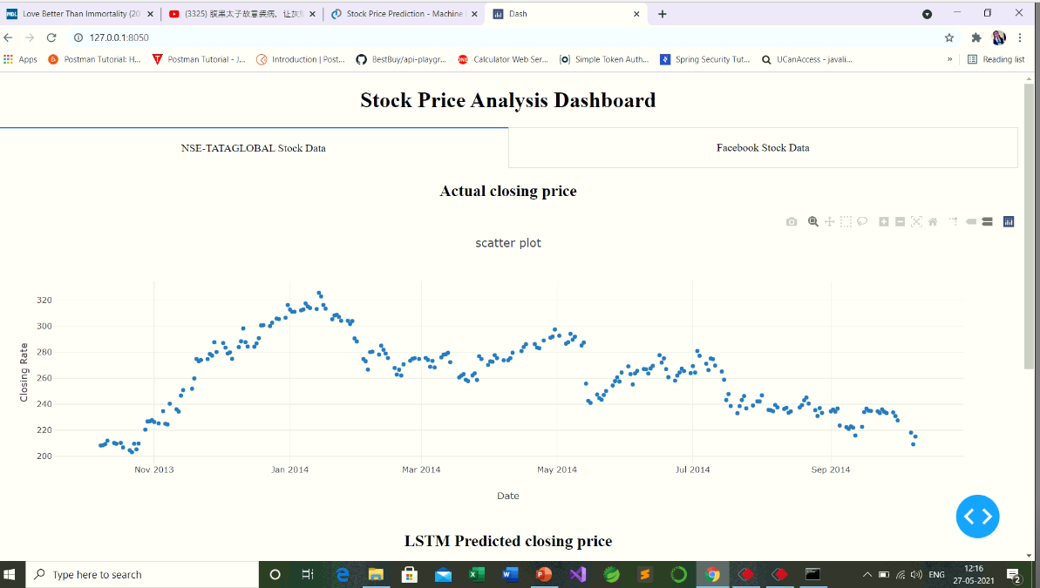

FUTURE WORK
In this Python project, we have worked on the dataset of tesla stock price up to certain year range. We will try our best to add new features like by increasing the range, so that it can be easily implemented under various situations, and also to increase more flexibility in all the modules.
(Initial future aim) : Moreover, our future aim is to create software along with a website that will analyse previous stock data of certain companies, with help of certain parameters that affect stock value. We are going to implement these values in data mining algorithms to predict more accurate result. This will also help us to determine the values that particular stock will have in near future. We will determine the Month’s High and Low with help of data mining algorithms.
(Updated Future aim): Initial future aim is already updated in this project. There are a couple of other techniques of predicting stock prices such as moving averages, K-Nearest Neighbours, ARIMA and Prophet. These are techniques that one can test on their own and compare their performance with the Keras LSTM. We will try to use these in our project in future to produce more accurate results.

CONCLUSION
Machine learning is the study of computer algorithms that improve automatically through experience. Machine learning algorithms build a model based on sample data, known as "training data", in order to make predictions or decisions without being explicitly programmed to do so. Machine learning algorithms are used in a wide variety of applications, such as email filtering and computer vision, where it is difficult or unfeasible to develop conventional algorithms to perform the needed task.

REFERENCES
1.)en.wikipedia.org
2.)tutorialpoint.com
3.)Ajith, A., Baikunth, N. &Mahanti, P. K. (2003a). Hybrid intelligent systems for stock market analysis. In Proceedings of International Conference on Computational Science.
4.)towardsdatascience.com
5.) https://www.analyticsvidhya.com

